ICT Project Guidance

Education Sector Service Types

Author:

Sky Sigal

## Description

This document lists and describes the service types that are specific in the education sector, along with their key capabilities and differences from general enterprise services.

## Synopsis

Education sector services manage the distribution of information necessary for young learners to self-manage and be productive contributors within an adult society. The information is disseminated in sequenced stages over approximately 11 years via trained disseminators to consumers subscribed to providers that procure and provide the group and individualised training facilities, transport, planning, support, and assessing.

## Contents

Description 1

Synopsis 1

Contents 2

Introduction 3

Heading Level 3 3

Network Management Services 4

Consumer Registry Service 4

Consumer Group & Relationship Management Service 5

Service Provider Registry Service 5

Service Workforce Management Service 6

Service Product Catalogue Service 7

Progress Assessment Services 7

Learner Support Registry 8

Learner Support Funding Registry 8

Achievements Registries 9

Appendices 10

Appendix A - Document Information 10

Images 10

Tables 10

References 10

Review Distribution 10

Audience 10

Structure 10

Diagrams 11

Terms 11

## Introduction

While state managed and obligatory for all young learners in society, education can be categorised using standard business categorisation terminology, and measurements.

### Heading Level 3

# Network Management Services

The sector’s network of providers is managed and supported by a number of logical services.

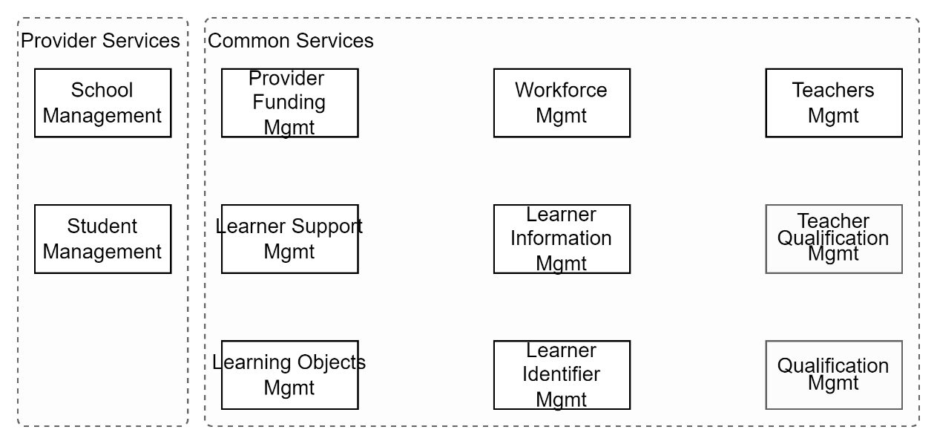

Figure : Common Education Sector Logical Capabilities

## Consumer Registry Service

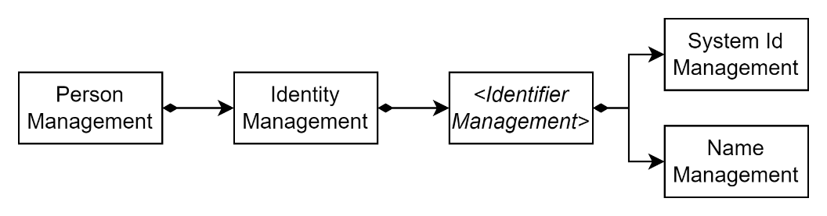

Figure : Consumer Registry Service Capabilities

A registry of lifelong learners is required to provide a unique identifier to facilitate attributing information across multiple digital and physical systems to the same learner’s identity.

As any person can be a learner, at any age, a key capability is to manage records of natural Persons for their full lifespan.

As a Person may have multiple distinct Identities over their lifespan, the system must be capable of managing the association of multiple Identities to a single Person.

To enable a person to keep the activities of their Identities separate, a unique system identifier is associated to each identity.

As an Identity may be known to have multiple Names, the system must be capable of managing multiple Names per Identity, with the option of defining one as their legal name if any, and another as their preferred name, if different.

The service must be capable of being integrated with by education network provider services to facilitate decentralised addition, management and validation of new consumers and the transfer of information between service providers.

Note:  
In New Zealand, the National Student Index (NSI) service is used to provide some of these capabilities.

## Consumer Group & Relationship Management Service

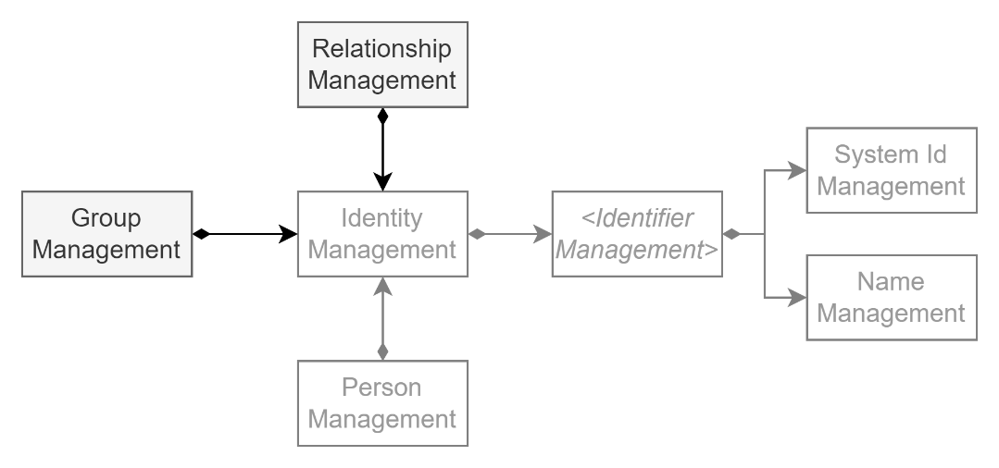

Figure : Consumer Group & Relationship Management Service Capabilities

Considering the young age of most consumers, other People have important relationships with them – whether they be Caretakers, siblings, or wh`anau.

There is therefore a need to manage records of People and Identities that are related or have another form of relationship with a Learner service consumer.

Additionally, People are organised as members of Groups. These groups can be Families, extended families, or state service groupings (boy’s home, etc.).

Recognising that – ideally -- most other persons will be Lifelong Learners at some point in their lives, there is an argument for adding this capability to a Consumer Registry Service.  
The fact that it is an ideal outcome is indicative of the opposite, and should not be the case, unless the Consumer Registry is made capable of managing persons that are not Learners.

Note:  
In New Zealand, some of these capabilities may become available as an outcome of the Te Rito programme.

## Service Provider Registry Service

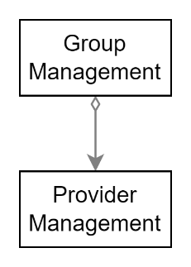

Figure : Service Provider Management Service Capabilities

A registry of service providers is required to manage records of education providers, the culture(s) they provide education in, the type(s) (primary, secondary, etc.) that best describes the establishment, its geographic location, its communication channels (post, web, email, phone, etc.).

Note:  
In New Zealand, two cultures co-exist, and therefore more than one curriculum exists.

As with any entity, they may already be or will part to a parent grouping, whether it be by an ad-hoc or official association, including being acquired, consolidated or absorbed. For example, Education Providers may be large schools that provide one or more of Early Learning, Primary and Secondary education, as well as parent Universities or polytechnics with nested schools (e.g., school of medicine, engineering, etc.). The service must be capable of facilitating the management of these groupings.

The service must be capable of being integrated with by education network provider services to facilitate decentralised addition, management of records, and development of reference data as required.

Note:  
In New Zealand, the FIRST service is used to provide some of these network management capabilities.

## Service Workforce Management Service

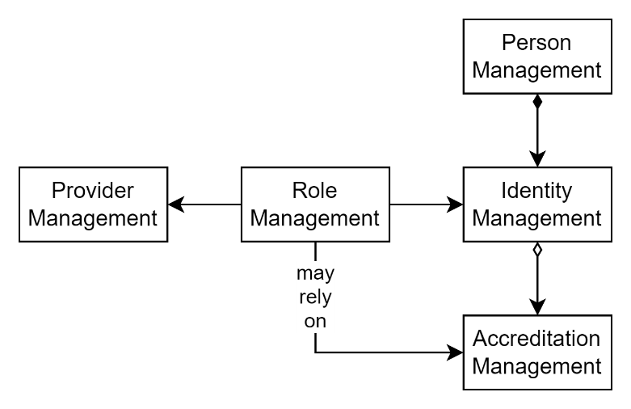

Figure : Service Workforce Management Service Capabilities

Education is provided by a Workforce composed of different abilities, some of which require accreditation.

A service registry of the workforce requires access to a current list of providers, the ability to created and manage roles specific to the provider and associate one of a person’s identities to the role.

Note:  
In New Zealand the closest there is to this service is TODO.

## Service Product Catalogue Service

A ministry’s primary product is its Curricula, and associated information defining outcomes, pathways, and assessment criteria.

Teachers are provided source material on what to teach, how to teach, when to teach, and guidance on how to judge and report on individual learner progress.

Curricula and associated material are made available in print as well as digital format.

A key capability required of the service is the ability to search, filter, the curricula and related material.

Note:  
In New Zealand, the digital products were available via TKI, which was retired and replaced by OCH.

Progression Planning Service

While a Curriculum provides a baseline national plan on what to teach, when to teach, the plan requires individualisation based on recognising and leveraging a learners strengths and need for support.

Note:  
In New Zealand, no national service is provided to manage the development of national, localised or individualised progression plans. Instead, teachers use their provider’s SMS and/or less integrated or digital solutions (e.g. hand crafted google based spreadsheets, etc.).

## Progress Assessment Services

A teacher’s key role is to progress a learner’s initial state of recognition or basic understanding of a specific domain of knowledge to being capable of applying it successfully to intended purposes.

This transition requires time and assessments of progress over this time, to better enable the teacher to ascertain strengths and weaknesses, to develop plans to best assist learners who may need assistance.

There are evolving and sometimes competing theories on which kind of assessment produces the best outcomes, ranging – at a very high level – from “Assessments *of* Learning” (AoL), through “Assessments for learning” (AfL) to “Assessments as Learning” (AaL).

Essentially -- and again, at a very high level -- AoL is performed after teaching, AfL is performed iteratively during the course to inform in-flight corrections to teaching practices, and AaL combines teaching resources and assessments into a combined self-guiding automated experience, permitting learners more agency in the pace they take to successfully progress through the material.

AoL and AfL can be performed by teacher judgement, based on observed evidence compared to defined standards, or by learners taking automated or manual tests scored against defined progression standards.

Note:  
In New Zealand, two key national systems exist to deliver AoL in primarily English and Maths: the Progress and Consistency Tool (PaCT) and Electronic Assessment Tools for Teaching and Learning (e-asTTle).   
The key difference between the two approaches is that e-asTTle is a test administered by teachers, taken by learners and scored automatically by automation, whereas PaCT is for assisting teachers to record Overall Teacher Judgements (OTJ) of learners, based on their having observed the learners ability to meet specified national standard expectations. An e-asTTle outcome can contribute to an OTJ.  
There is no national service to provide an AaL based approach to learning, potentially leveraging material within OCH.

## Learner Support Registry

Learners are varied and come from varied backgrounds. Some may require assistance and support to compensate for limitations that are outside their control.

Advantages:

* The system facilitates the observing, recording, monitoring of learner needs
* The system facilitates the requesting for financial assistance for learners
* The system facilitates the monitoring of outcomes.

Considerations:

* The system requires integration with the Education Provider Registry service.

Disadvantages:

Recommendations:

* Ensure systems are able to or improved so as to be capable manage the funding of education provides with sufficient capability of associating the learning directly to supported Learner Identities.

Note:  
In New Zealand support of learners is performed at the provider level, primarily via their chosen SMS, who submit applications for support assistance on behalf of learners in need. There is not a national registry of learner’s support needs and associated notes as to the outcome of assistance.

## Learner Support Funding Registry

Learners with support needs may need financial assistance. A registry is required to manage applications, acceptances, invitations to agree to terms and conditions, and expectations, disbursements, and management of impact assessments.

Note:  
Applications for support are received from schools and funds are allocated to the school, not the benefiting learner.

## Learning Object Repository (LOR) Service

While not a standard, it is an approach to developing repositories of Learning Object[*ives*].

Advantages:

* A central store of learning objects (LO)s is easily discoverable.

Considerations:

* The service type has been around for several decades, but basic design assumptions has led to it not being as usable as originally envisioned, therefore not being widely adopted.

Disadvantages:

* the basic design issue that limited its wide adoption is that it doesn’t manage *information*, but instead manages *packages* of information. The difference is subtle but important: when a well-intentioned user uploads a learning object package to share with others and categorises it by metadata, it is common for other users to appreciate it, but require localisation of the information -- which they may package and upload and categorise slightly differently. The result is fragmentation, duplication, that -- combined with search facilities limited by the quality of the classification metadata used – is a frustrating experience for subsequent users. The alternative, where resources are developed by an authoritative source, have fared in some ways worse -- due to underfunding the high centralised costs (compared to distributed volunteer effort), subsequent descoping, leading to delivering a resource that is thin in breadth and/or width.
* Other design limitations of previous and current LORs include the lack of relationship management between learning objects and/or their content, that does not permit the development of recommended paths to use for progression planning,
* limited permissions management, developed at a national level, without consideration for national and local control,
* limited to no endorsement management,
* etc.
* While there are legacy systems that have been open sourced or are still managed in some fashion, and LMSs that provide some LOR functionality, there is no current and ongoing credible development of LOR services.

Recommendations:

* Avoid: LORs as currently designed exist but are unsuitable for current education needs.

Note:  
In the New Zealand Education sector, the closest the ministry provides the capabilities of LOR may be the OCH service.

## Student Management Services (SMS)

A student management service is used by schools to organise:

* Teachers
* Learners
* Course
* Resources
* Timetables
* Progress Plans

Advantages:

* The system is meant for addition and management of information by school workforce closest to source for regular use, and therefore is of high data currency and validated quality.

Considerations:

* Individual SMS benefit by integrating with authoritative sources:
  + Workforce:
    - E.g., a workforce registry, containing names & qualifications.
  + Learners:
    - Learner identifiers registry (name & cross-system identifier)
    - Optionally, Learner information data-hub (personal, pastoral, pedagogical planning & progression)
    - An achievements registry.
  + Parents:
    - A group & relationship registry if one is available.
  + Funding:
    - An authoritative enrolment registry.
    - Funding services
* Disadvantages:
  + When the service is not provided on a national level, the market fills the void with different solutions, each with varied capabilities (functionality, security, interoperability, modularity, maintainability, etc.)
  + When the service is provided at a national level, they have in the past not been developed in a responsive iterative and long-term manner to meet all user desired outcomes. Providers will then turn to the market to find solutions that are more appropriate to their needs, potentially leading to fragmentation, double entry, data entry errors, etc.
* Recommendations:
  + Due to the varied quality of capabilities, functionality, modularity, development skills, framework and platforms used impacting maintainability and incremental improvability of each platform, it is recommended to make available a wide range of integration approaches suitable for a varied workforce and platform constraints – rather than expect all providers to implement a common integration approach they may not be able to do.

Note:  
In New Zealand’s Education Sector, SMSs suffer from all of the above issues to varying degrees. Regarding addressing integration needs, the Te Rito program is being implemented so as to provide multiple integration approaches, ranging from import only to two-way communication, over HTTP/S, using a range of integration approaches, including ETL to ODBC endpoints, SOAP services and RESTful API endpoints.

## Achievements Registries

While assessment results are private information managed by education providers on behalf of learners, learners aim to develop public recognition of their achievements in different domains.

There are varied and competing theories on how best to test and report on achievements, as well as publishing results.

The traditional approach is to develop “high stakes” tests that are sit under controlled conditions, overseen by test proctors. The tests are considered “high stakes” as they generally summarise in on sitting several years of work in a domain, cannot easily be retaken -- while their results determine what further educational options can be followed. Or not.

This approach contrasts with emergent “micro-credentials” which are iteratively obtained by passing smaller assessments throughout the course. Micro credentials permit focusing on only the aspects one believes one needs, and easily showing competence in these areas (see Open Badges).

Note:  
In New Zealand, the management of high stakes achievements achievement tests and results is managed by services provided by New Zealand Qualifications Authority (NZQA). There is no national repository for managing the taking, publishing of micro-credentials.

Appendices

Appendix A - Document Information

### Images

Figure 1: Consumer Registry Service Capabilities 4

Figure 2: Consumer Group & Relationship Management Service Capabilities 5

Figure 3: Service Provider Management Service Capabilities 5

Figure 4: Service Workforce Management Service Capabilities 6

### Tables

### References

**There are no sources in the current document.**

### Review Distribution

The document was distributed for review as below:

|  |  |
| --- | --- |
| Identity | Notes |
| Sandy Britain, Enterprise Architect |  |
| Marg McLeod, Strategic ICT Business Advisor |  |
| Derek Wenmoth, Strategic ICT Business Advisor |  |
|  |  |

### Audience

The document is technical in nature, but parts are expected to be read and/or validated by a non-technical audience.

### Structure

Where possible, the document structure is guided by either ISO-* standards or best practice.

### Diagrams

Diagrams are developed for a wide audience. Unless specifically for a technical audience, where the use of industry standard diagram types (ArchiMate, UML, C4), is appropriate, diagrams are developed as simple “box & line” monochrome diagrams.

### Terms

Refer to the project’s Glossary.

##### IT

: acronym for Information, using Technology to automate and facilitate its management.

##### ICT

: acronym for Information & Communication Technology, the domain of defining Information elements and using technology to automate their communication between entities. IT is a subset of ICT.